Name: Vaishnavi Jeevan Shirke
RollNumber:-MCA2504097
LAB-3
Task: Jenkins Installation Using Docker

Step 1: Pull Jenkins LTS
docker pull jenkins/jenkins:lts
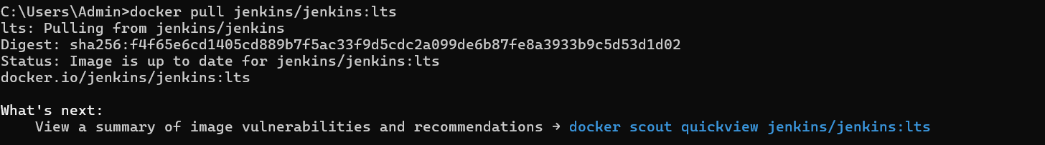
Step 2: Create a Docker Volume
docker volume create jenkins_home
Step 3: Run Jenkins
docker run -d --name jenkins -p 8080:8080 -p 50000:50000 -v jenkins_home:/var/jenkins_home jenkins/jenkins:lts

Step 4: Get the Initial Password
docker exec jenkins cat /var/jenkins_home/secrets/initialAdminPassword
I have already logged in so thats why I am getting an error message

Step 5: Open it
http://localhost:8080
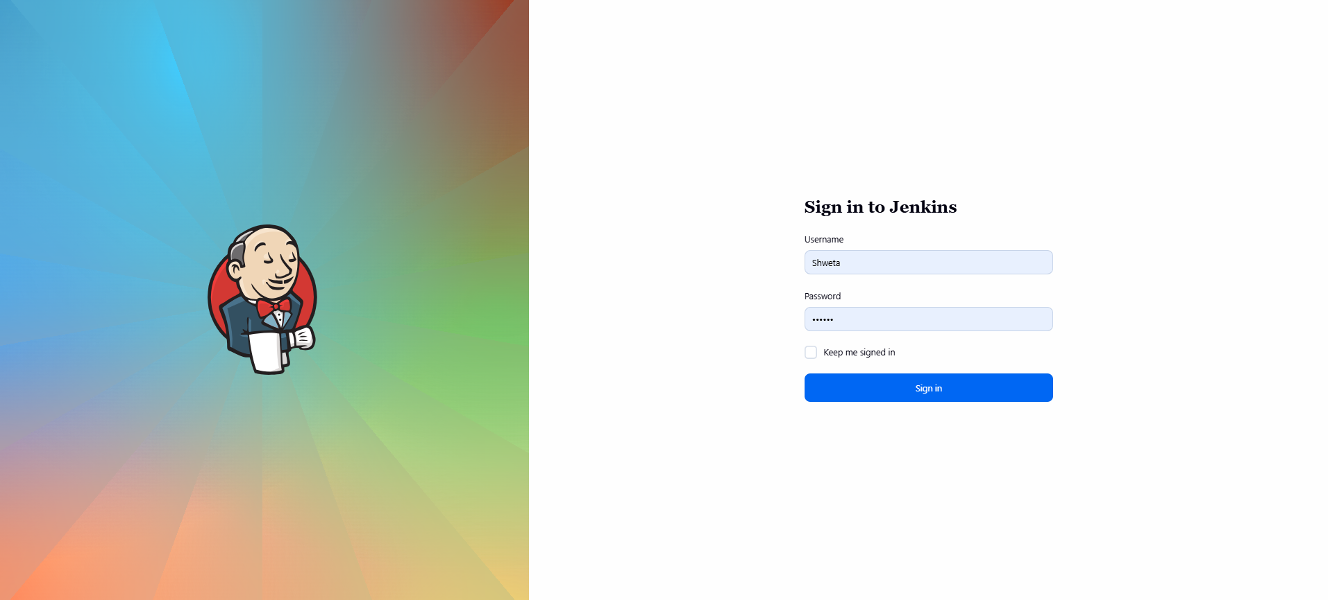

PART 2:
First Pipeline:
From Jenkins Dashboard:
New Item
Name:
MyFirstPipline
Select:
pipeline
Click Ok
Scroll to:
Pipeline
Choose:
Pipeline Script
IN IT PASTE THIS CODE:
pipeline {
agent any
stages {
stage('Hello') {
steps {
echo 'Hello Jenkins'
}
}
stage('System Info') {
steps {
sh 'hostname'
sh 'whoami'
sh 'pwd'
sh 'ls -la'
}}
stage('Finish') {
steps {
echo 'Pipeline Completed Successfully'}}}}

Click:
Save
Then click:
Build Now
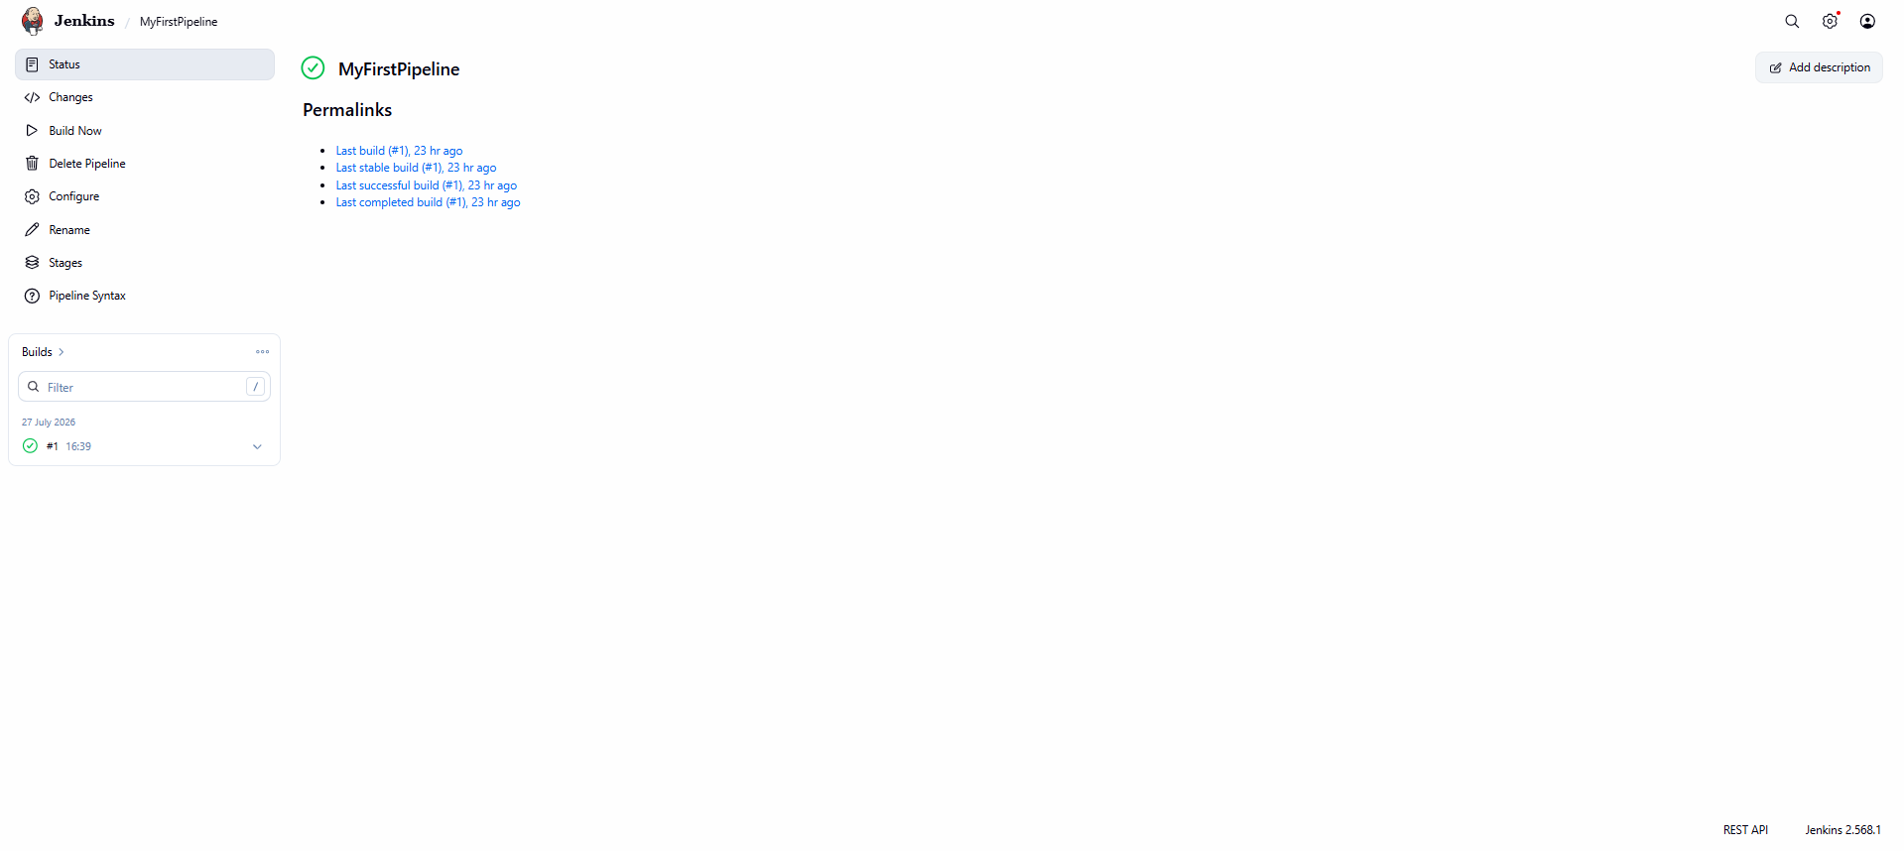
OUTPUT:
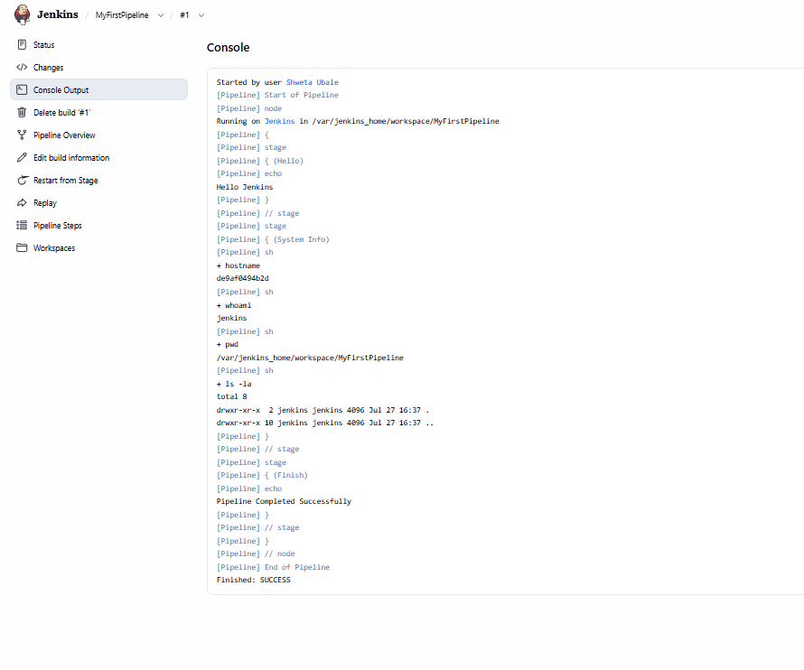

Step 3 : Build Your First Project
Create a folder
DevOpsLab
Inside it create
index.html
<html>
<head>
<title>DevOps Lab</title>
</head>
<body>
<h1>Hello Jenkins Pipeline</h1>
</body>
</html>

Create
Jenkinsfile
pipeline {
agent any
stages {
stage('Checkout') {
steps {
echo 'Checking files'
}
}
stage('List Files') {
steps {
sh 'ls -la'
}
}
stage('Read HTML') {
steps {
sh 'cat index.html'
}
}
}
}

Lab 4: Connect Jenkins with Git
Install Git on your system.
Go to:
Manage Jenkins
↓
Tools
↓
Git
Provide Git installation.

Create a GitHub repository
DevOpsLab-Pipline
Push
index.html
Jenkinsfile

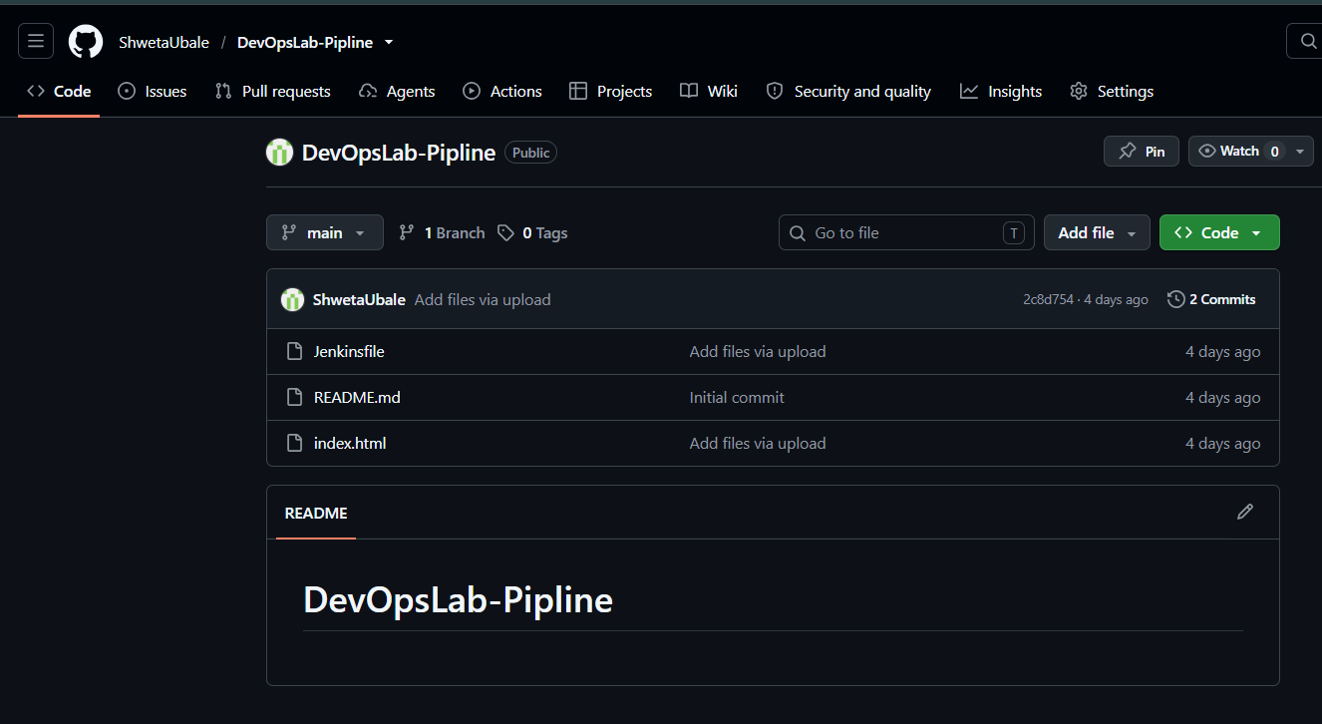

Now Create a new pipeline:
DevOpsLab
Now Instead of Pipeline choose:
Pipeline script from SCM
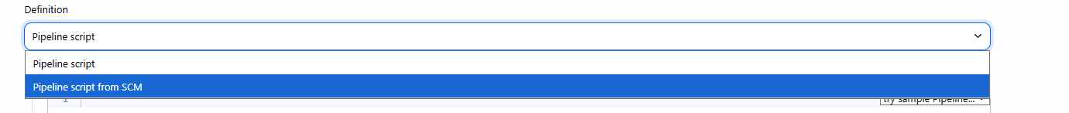
SCM:
Choose GIT
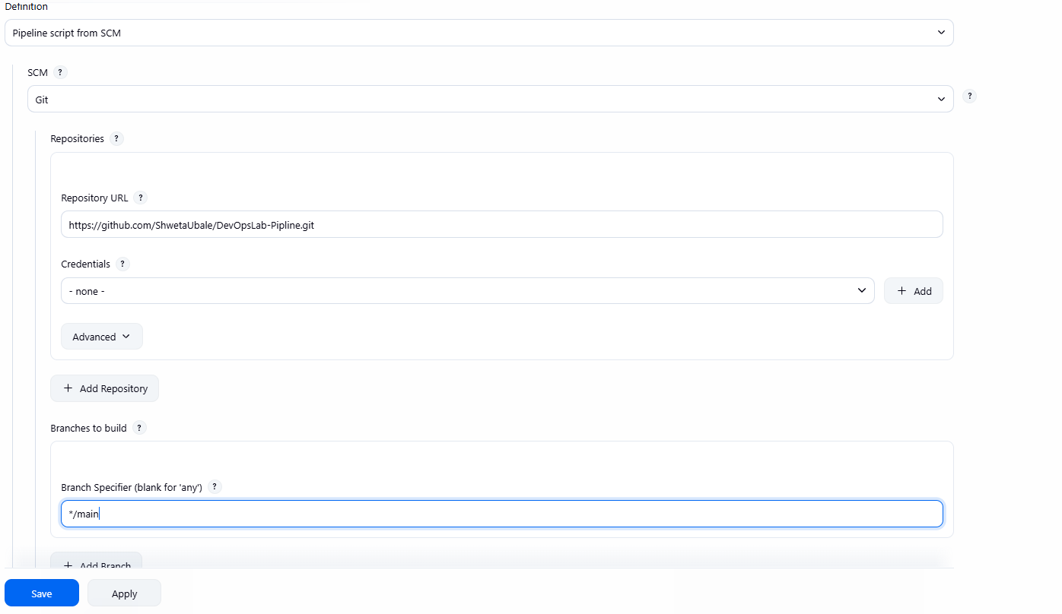
SAVE and BUILD:
